For this laboratory you will have to download the Laboratory_3.zip file that is attached in the page for Laboratory 5. You will find a simple HTML page with some text blocks, a header and footer. At the moment these blocks are unstyled. You will have to create a layout that looks like this on mobile phones:

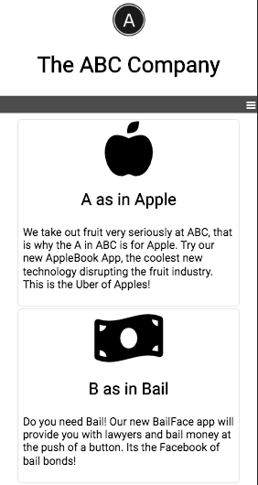

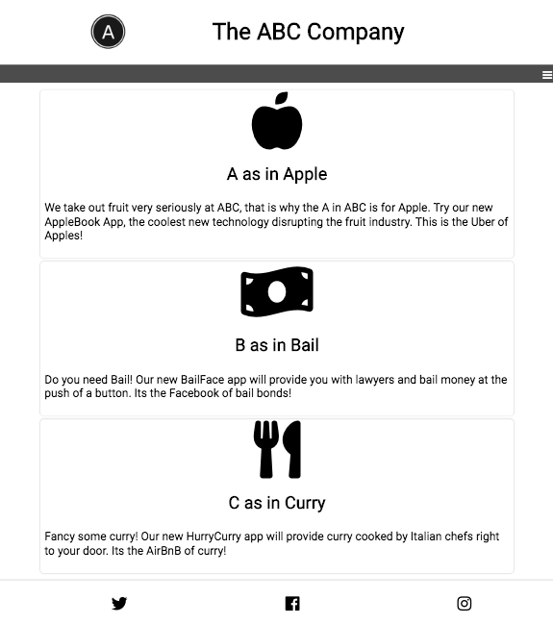

**This on tablets:**

**And this on larger screens:**

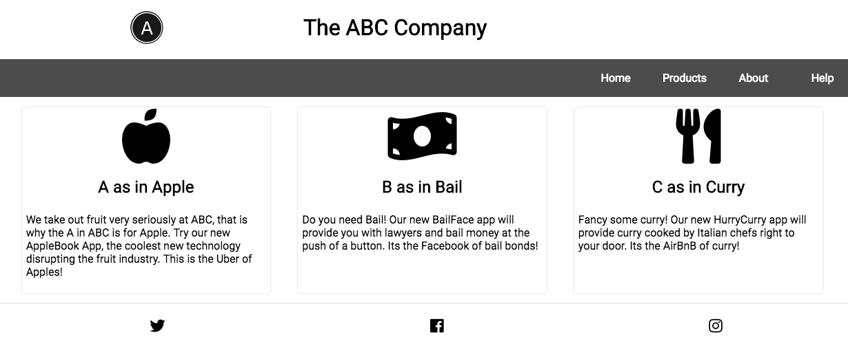

Use media queries and flexbox to create the desired layout. In this laboratory, you should start by determining the breakpoints, then identifying the flex container or containers. Write your code in the index.css file.

**This lab must be delivered on Friday September 6th by 11:59PM. It is an individual exercise. When you're done, post this to a Github and submit it via the google site on your profile under a new page named in the following way:**

**StudentID_Lab3**

**Example: AlfredoSalazar45_Lab3**

**In that Page you must add in the edit box the URL of the created Github.**